**Air University Islamabad, Multan Campus**

**Computer Science Department**

**Report Title:**

Shopping Cart System in C#

**Submitted To:**

Mrs. Aatika

(Course Instructor of Visual Programing)

**Group Members:**

Faizan Ali (233574)

Fahad Ashraf (233586)

Sarim Ahmad (233568)

**From:**

BS CS (B)



**Shopping Cart System in C#**

**Project Overview:**  
The Shopping Cart System is a simple console application developed in C# that allows users to add, remove, view, and check out products from a cart. This project simulates a basic shopping cart system where users can manage items and see the total cost in PKR. It demonstrates object-oriented programming principles such as encapsulation, modularity, and user interaction through the console.

**Objectives:**

* Implement basic CRUD operations for items in a shopping cart.
* Provide a user-friendly console interface with clear options and feedback.
* Calculate and display the total cost in PKR for all items in the cart.

**System Functions and Features**

**Product Class**  
Represents a single product with properties for Name and Price. This class serves as a model for items that can be added to the cart.

**Code:**

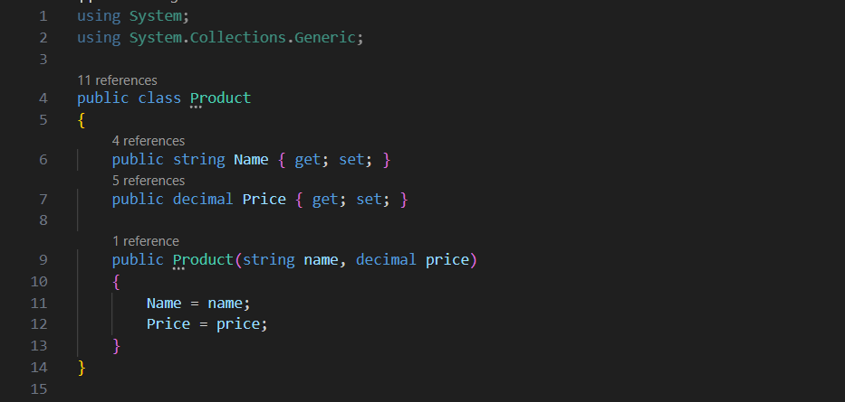

**Cart Class**  
Handles operations related to the shopping cart, such as adding, removing, viewing products, and checking out. The cart does not directly store products; instead, it operates on a list of products provided by the main program.

**Functions in Cart Class:**

**Add Product:** Adds a new product to the cart.

**Code:**

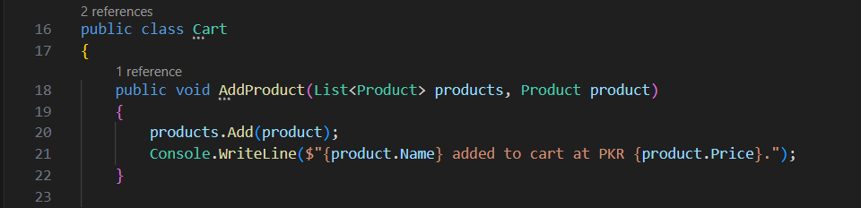

**Remove Product:** Removes a specified product by name.

**Code:**

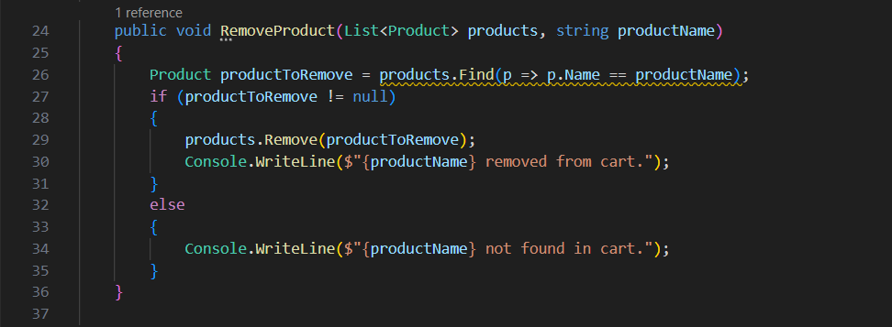

**View Cart:** Displays all products currently in the cart and the total cost in PKR.

**Code:**

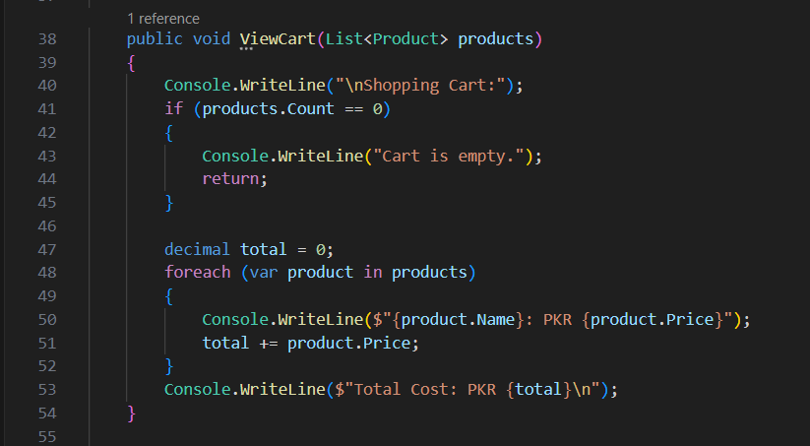

**Checkout:** Calculates the final total cost and simulates the checkout process if the cart has items.

**Code:**

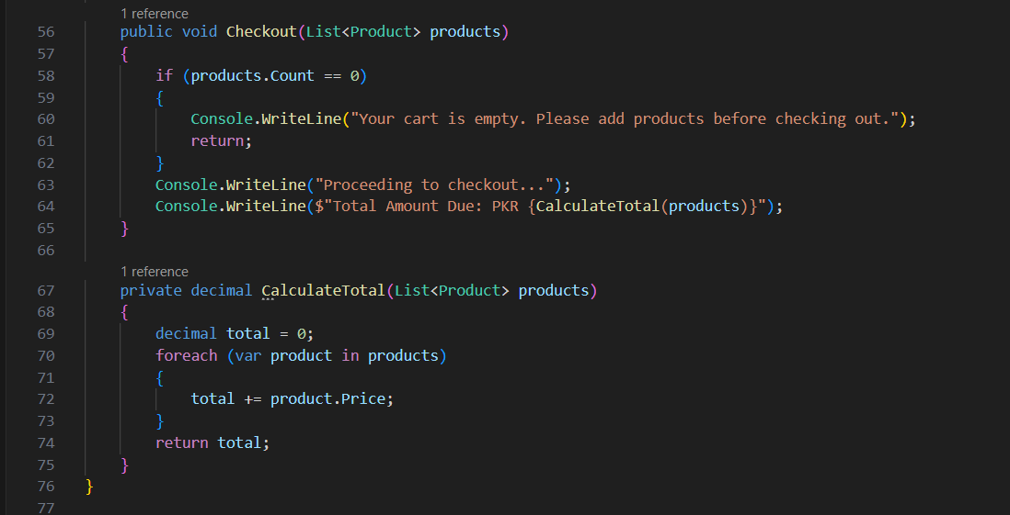

**Program Class (Main Program)**

The entry point of the application, providing a user interface that allows users to interact with the cart and manage products.

* **User Menu:** Presents options for adding, removing, viewing, and checking out products in the cart, including decorative elements for a user-friendly interface.

**Code:**

**Menu:**

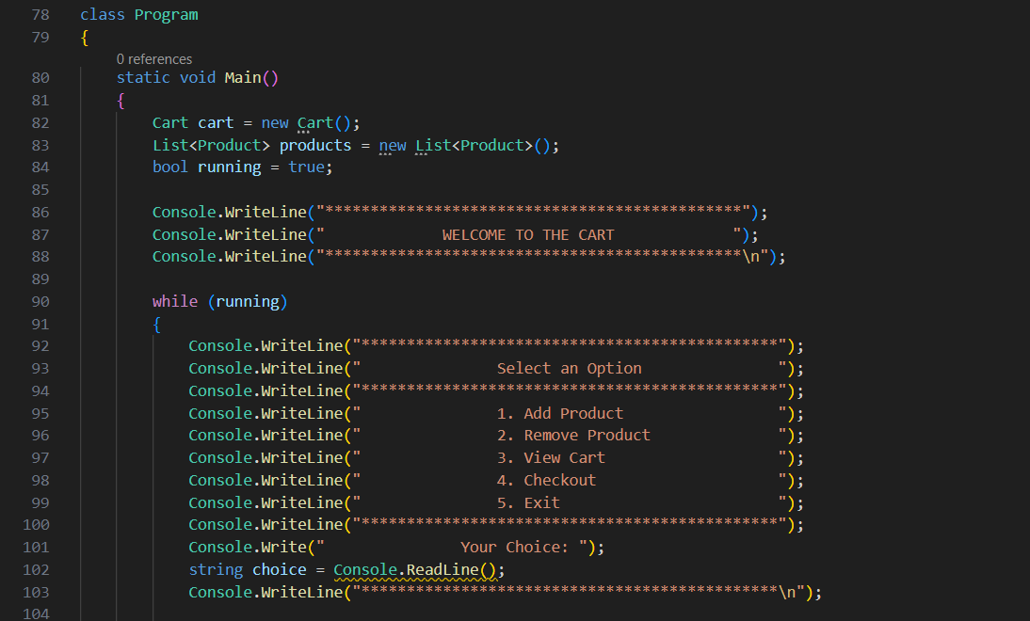

**User Choice:**

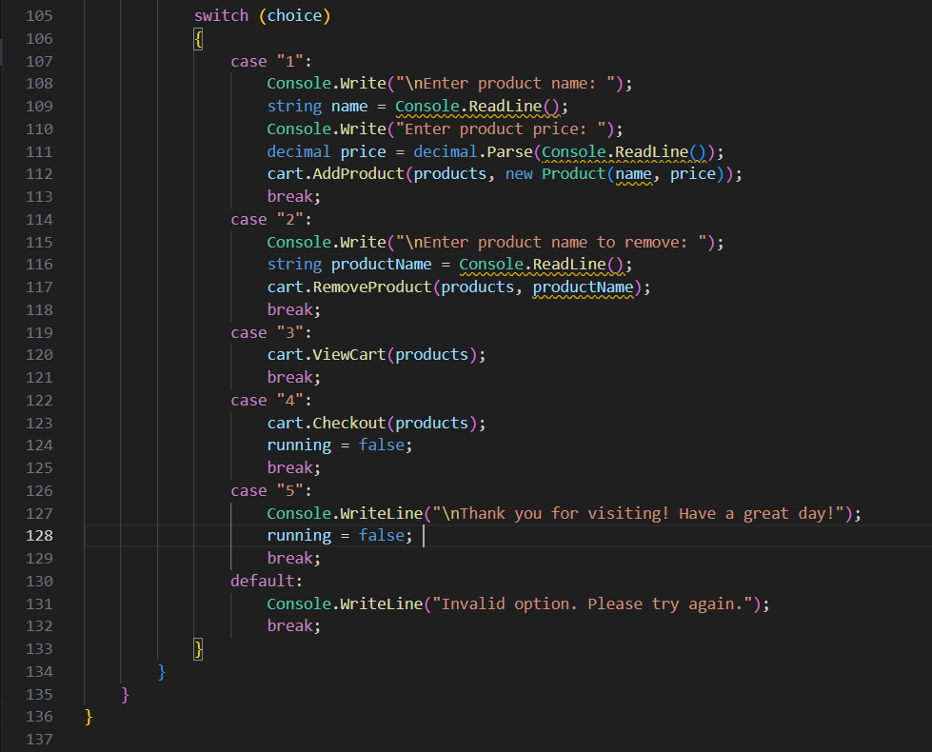

**Sample Console Interface**

**Conclusion**

This mini-project effectively demonstrates the basics of object-oriented programming in C#. It provides an interactive shopping cart experience with functionalities like adding, removing, viewing, and checking out items. The project’s modular structure ensures that each component, such as Product and Cart, has clearly defined responsibilities, making the codebase easy to understand and maintain.

**This application could be expanded with features such as:**

* Persistent storage of cart data,
* Product categories,
* Discounts and taxes calculations.